Strand 1: Science Learning, Understanding and Conceptual Change
Administrative ESERA Sponsored Session. Admin Symposium:

How Effective is Education for Sustainable Development at School? Findings from Recent Studies across Europe

2:40pm – 4:10pm, Hyatt Lone Star E

Proposer: Prof. Anna Uitto, Faculty of Educational Sciences, University of Helsinki, Finland

Presenters:
Anna Uitto, University of Helsinki, Finland
Jelle Boeve-de-Pauw, University of Antwerp, Belgium
Niklas M. Gericke, Karlstad University, Sweden
Daphne Goldman, Beit Berl Academic College, Israel Dorit Baum, University of Haifa, Israel

How effective is education for sustainable development in the context of formal education? Findings from four large-scale studies

Despite the increasing implementation of sustainability education (SE) within formal education, information on its effectiveness is scarce. This symposium presents findings from empirical studies with quantitative and mixed-method designs that explore the impact of SE in primary and secondary education in Sweden, Belgium, Israel, and Finland. The studies reveal nuanced and not always positive impact of SE. Swedish students’ sustainability learning outcomes (SLO) were slightly higher for some students but lower for others when certified SE schools are compared to reference schools. Israeli students’ SLOs and school’s environmental-performance were higher in schools that advanced to higher accreditation-level ('ongoing-green') while achievements in basic-level-accredited ('green') schools were lower than in reference schools. The eco-school program in Belgium increased specific SLOs (mainly knowledge), but also it fostered controlled motivation rather than autonomous motivation for acting sustainable way. However, the Finnish study found that through sustainability self-efficacy, pro-environmental values and norms, in-school pro-social and agency experiences are able to enhance students’ SLOs. Overall, despite widespread implementation of whole-school SE-programs, their educational effectiveness requires improvement. The symposium will address the importance of focusing on educational and school-organizational processes that foster student’ SLOs, and argue for SLO assessment as an integral component of SE-program implementation.

Influence of Green-school-certification on pupils’ environmental literacy and schools’ adoption of sustainability

Daphne Goldman¹, Bell Weiss², Dorit Baum² and Ofira Ayalon²
¹Beit Berl Academic College, Faculty of Education, Department of Environmental Science and Agriculture
²University of Haifa, School of Management, Department of Natural Resources and Environmental Management
dafnag@netvision.net.il; weissbell@gmail.com; DoritB@sviva.gov.il; ofira@sni.technion.ac.il

Abstract
‘Green-school’ certification is one of the major projects conducted to promote meaningful environmental education in Israel. This Whole-School Approach integrates: changes in school operations, sustainability issues in the curriculum and building links with local communities, addressing all school-community stakeholders. No studies have explored achievements of this certification process. This study investigated its influence on pupils’ environmental literacy (EL) and on adoption of sustainability within school organizational culture. Pupils’ EL-characteristics (knowledge, affects, behaviour), and ‘environmental-visibility’ of school settings were compared among schools in different stages of green certification (requesting certification; certified green; certified ongoing-green; unrelated to certification). A closed and open-ended EL-questionnaire was administered to 403 6th-grade pupils in eight public schools, two schools for each certification stage. Adoption of sustainability within school culture was evaluated by direct observations of school settings using an ‘environmental-visibility’ tool which includes 52 criteria addressing infrastructure, management, educational activities and public outreach, and distinguishes between basic and more advanced sustainability practice. Contrary to expected, no differences were detected in quantitative measures of EL among pupils from different school groups. Qualitative components proved more sensitive in detecting subtle differences. For example, pupils from ‘ongoing-green’ schools provided advanced examples of environmental issues for which the majority of pupils reported limited knowledge. ‘Ongoing-green’ and schools in-certification-process featured highest levels of ‘environmental-visibility’, while ‘green’ schools featured low ‘environmental-visibility’, similar to that of schools unrelated to certification. Results enable recommendations for updating the certification process. For example, for recycling and cleanliness (a focus of certification in its early years) pupils express high levels of knowledge and responsible behaviour. They don’t relate between their personal consumption behaviors and environmental consequences. Certification should advance from emphasis on recycling to address deeper changes such as consumption and related values. ‘Environmental-visibility’ results indicate that a challenge of certification is maintaining its achievements over time.

Key words: green school certification, environmental literacy, sustainability practice

1. Introduction
‘Green-school’ certification, initiated in 2004 by The Ministry of Environmental Protection (MoEP) as a component of the national Israeli SD strategy, is one of the major projects conducted to promote meaningful environmental education for sustainability. This Whole-School Approach integrates among: changes in school operations, incorporation of sustainability issues in the curriculum and building links with local communities (Gough, 2005; Henderson & Tilbury, 2004), addressing all stakeholders in the school community. The ambition of ‘green-school’ certification is to improve the environment through direct processes (adopting sustainable lifestyles and implementing environmental management within schools) and indirect processes )long-term educational gains achieved by changing the way children, as future citizens, comprehend, perceive and interact with the natural world) (Boeve-de Pauw & Van Petegem, 2011). The philosophy underlying this approach is that certifying ‘green’ educational institutions promotes environmentally-responsible thinking as a mindset, so that children, as future consumers, manufacturers, scientists, decision-makers and educators, will be deeply sensitized to the environment, thus environmental considerations will be more central in decision-making.
Over 700 public schools have been certified ‘green’ and 70 certified ‘ongoing green’. To date there is a shortage of studies exploring achievements of the ‘green-school’ certification in terms of learners’ environmental literacy, and adoption of sustainability as school culture. A step in that direction, this study focused on two research questions: Effectiveness of the certification process on development of pupils’ environmental literacy (EL) and citizenship; Effectiveness of the process on incorporating sustainability within school organizational culture.
2. Method
The study compared EL-characteristics (cognitive, affective and behavioral) of pupils and the ‘environmental-visibility’ of school settings among eight schools (with same socio-economic index) which are at different stages of green-certification (requesting certification; certified green; certified ongoing-green; not connected to certification), two schools for each certification stage. The hypotheses were that the more advanced the school is in the certification process (i.e. longer involvement in sustainability), the more developed will be the learners’ EL resulting from more extensive exposure to sustainability via studies and school-life, and the more significant will be the incorporation of sustainability within school settings and functioning (greater ‘environmental-visibility’).
The study employed a mixed-method approach: EL of 403 6th-graders was evaluated by a closed and open-ended questionnaire which examined their knowledge, attitudes and sense-of-personal-responsibility regarding environmental issues; willingness to conduct environmentally-responsible actions at school and home; and self-reported involvement in environmentally responsible behaviours (REB) that are relevant for children and reflect increasing environmental commitment. Incorporation of sustainability principles by schools was evaluated by a combination of questions in the questionnaire (pupils’ perception of school involvement in sustainability practice), interviews with school administration and direct observations of school settings using an ‘environmental-visibility’ tool developed by the MoEP. This tool includes 52 criteria addressing infrastructure, management, educational activities and public outreach, and distinguishes between basic and more advanced sustainability practice.
ANOVA examined for differences in quantitative EL-measures among school groups. Written components (examples/explanations) were categorized (not-provided, incorrect, correct, advanced) and Chi-squared-for-independency examined for differences. Points accumulated by each school on the ‘environmental-visibility’ monitoring tool were summed.
3. Results
95% of the pupils, regardless of the stage in certification, agreed that children should act on behalf of the environment; recycling and cleanliness were indicated as main areas of contribution. The main differences among pupils from different school groups were the use of scientific language, depth of explanations and diversity of areas for contribution, which increased with the stage in certification.
In all quantitatively measured EL-parameters, no significant differences were detected among pupils from the different groups of schools. Pupils feel they are moderately knowledgeable about environmental issues (3.15/5±0.70); demonstrate slightly pro-environmental orientation (3.38/5±0.63); despite their agreement that children should behave pro-environmentally, they are willing to conduct REBs sometimes (3.05/5±0.80) and they practice REBs less than sometimes (2.68/5±0.73). They felt most knowledgeable about topics which are included in the school-curriculum (examples: causes of animal extinction 3.77/5±1.05, non-renewable materials 3.66/5±1.17), but were not familiar with consumer-related topics (ecological footprint 1.56/5±0.79, consumerism as an environmental problem 2.74/5±1.38). Correspondingly, they supported animal rights (4.36/5±0.93), but had difficulty deciding about the environmental-impact of their family’s shopping (3.00/5±1.24) and expressed limited willingness to reduce purchase of clothes or personal electronic-gadgets (2.42/5±1.39, and 2.73/5±1.43, respectively). They are only limitedly willing to talk to their neighbors about recycling (2.14/5±1.24) and seldom inform their parents or local authorities if they see a leaking pipe (2.22/5±1.18). Thus, it appears that these youngsters do not relate between their personal consumerism and environmental impact, and their involvement in REB is limited when personal investment is required.
Qualitative assessment was more sensitive in detecting differences among pupils from groups of schools, which were subtle. Such differences existed mainly in the knowledge domain, similar to results reported by Boeve-de Pauw and Van Petegem (2011). For example, pupils from ongoing-green schools provided advanced examples for environmental issues for which the majority of pupils felt limitedly knowledgeable. Conversely, for topics covered in the school curriculum, which pupils felt more knowledgeable about, pupils from schools unrelated to certification stood out in their provision of advanced examples. Pupils in this (no-certification) group were also able to best explain the environmental implications of different actions (replacing functioning cellphone with newer version; building neighborhoods in open areas; bringing lunch in lunch-boxes instead of plastic bags; carpooling).
Ongoing-green and schools in-certification-process scored highest in their ‘environmental-visibility’. Ongoing-green schools demonstrated unique motifs (ecological gardens, winter pools, themed educational activities). Schools-in-process reflected extensive involvement in “newly-acquired” environmental activities (green-committee, use of school-walls to display environmental involvement). Green schools had low ‘environmental-visibility’ scores, similar to that of schools unrelated to certification, and their school surroundings indicated stagnation with respect to environmental activity. Waste-separation and water-saving devices, which are supported by the municipality, existed in all schools.
4. Discussion
Findings indicate that, contrary to the hypothesized, students with more extensive exposure to sustainability via studies and school environment (ongoing-green) were not more willing to conduct REBs that entail some personal tradeoff, and did not demonstrate greater environmental citizenship in comparison to their counterparts from no-certification schools. It is evident from the study that regarding recycling and cleanliness- topics which were one focus of certification in its early years, receive media exposure, and are currently supported in schools by the municipalities independently to green certification- pupils are knowledgeable and express responsible behavior. A significant finding, in line with a growing body of evidence from other countries, is that children do not relate between their personal consumption and its environmental consequences. Since consumption is a major component of EF in western society, a recommendation for updating the certification process is that educational attention move from emphasis on “light-green changes”, such as recycling, to address deeper transitions in lifestyles, such as consumption and associated values. A challenge of the certification mechanism is to maintain sustainability of its achievements over time, since ‘environmental-visibility’ findings indicate that some of the certified schools have lessened their efforts. The increase in environmental performance of schools that remain dedicated to the incorporation of sustainability principles within school culture has yet to be paralleled by the educational gains of the students.

5. References
Boeve-de Pauw, J. & Van Petegem, P. (2011). The effect of Flemish eco-schools on student environmental knowledge, attitudes, and affect. International Journal of Science Education, 33(11), 1513-1538.
Gough, A. (2005). Sustainable Schools: Renovating Educational Processes. Applied Environmental Education & Communication, 4(4), 339-351.
Henderson, K. & Tilbury, D. (2004). Whole-School Approaches to Sustainability: An International Review of Sustainable School Programs. Report Prepared by the Australian Research Institute in Education for Sustainability (ARIES) for The Department of the Environment and Heritage, Australian Government.

The educational impact of eco-schools on students and teachers
Jelle Boeve-de Pauw & Peter Van Petegem
University of Antwerp, Belgium
Jelle.Boeve-dePauw@uantwerpen.be, peter.vanpetegem@uantwerpen.be

Abstract
Eco-schools is a large school environmental education program that is implemented around the world. It’s aims are to decrease the impact of school on the natural environment through direct and indirect effects. Those indirect effects relate to how different target groups perceive and interact with the natural environment. The current study presents findings on the effectiveness of eco-schools in Flanders. It looks into their impact on students’ and teachers’ knowledge (both theoretical and applied), values (preservation and utilization) and motivation (intrinsic, extrinsic, amotivation). The study includes 2152 students and 1374 teachers from 56 primary (grade 6) and 45 upper secondary schools (grade 12). Results show that the main impact is on theoretical knowledge, and that the program fosters extrinsic rather than intrinsic motivation. The study also examines the impact of the schools’ environmental policy-making, didactics and green elements on the educational outcomes of the program. We conclude that in Flanders, the eco-schools program might not be reaching its potential but that our results can be instrumental in doing so.

1. Introduction
Since the Industrial Revolution, human activities have led to the disruption of ecosystems to an extent that is increasing exponentially. An important way of raising awareness is the establishment of environmental education initiatives (UNESCO, 1978; United Nations, 2014). This is particularly important for young people, because they will ultimately be affected by, and need to provide, solutions for environmental problems arising from present-day actions. Therefore, effective environmental education is crucial. Eco-schools are schools that have engaged in a program that aims to better the environment directly through the adoption of an environmental management system, and indirectly by changing the way students perceive and interact with the natural world. Currently, the eco-schools program is being implemented in 47 countries around the world, involving 32,156 schools (9898 of which have already been certificated), 9,125,460 students, 628,005 teachers, and 5013 local authorities. The current study focuses on the effects of Flemish schools’ participation on the educational outcomes in students and teachers.
2. Aims and methods
Earlier studies have shown that the program, as implemented in primary education in Flanders, impacts mainly on the students’ knowledge, but fails to reach behavior change of increased environmental connectedness or attitudes (Boeve-de Pauw & Van Petegem, 2011, 2013). The current study aims to quantify the effect of schools’ participation in the eco-schools program on students’ and teachers’ environmental knowledge, environmental values (Bogner & Wiseman, 2006), and motivation towards the environment (Pelletier & Sharp, 2008). Several studies exist that that have compared eco-schools to control schools (e.g. Boeve-de Pauw & Van Petegem, 2012; Krnel & Naglic; 2009, Ozsoy, Ertepinar, & Saglam, 2012). The current study moves beyond that in two concrete ways.
(1) We examine differences between schools in different stages in the program.
(2) We do not just look at the differences but also aim to explain them.
In Flanders, eco-schools are accredited logos. These are a tree-step quality label: logo 1, logo 2 and logo 3. The eco-schools program encourages schools to maintain their efforts, even after they have obtained the logos, so that they can obtain the Green Flag of the Foundation for Environmental Education. We relate differences in effectiveness across these stages to differences in schools’ environmental policy-making (shared leadership, supportive relations, and common goals; Boeve-de Pauw & Van Petegem, 2014), in didactical approaches (rules-centered vs. integrated) and the presence and use of green elements at school. The study includes 2152 students and 1374 teachers from 56 primary (grade 6) and 45 upper secondary schools (grade 12). The impact of explanatory variables on the educational outcomes was estimate through multilevel regression modeling.
3. Results and Discussion
What are the differences?
Table 1 gives an overview of the effects across all schools. The eco-schools program manages to provide knowledge to students in grades 6 and 12 that the students in control schools do not get. Eco-school students have more theoretical and applied knowledge, which allows them to make choices with respect to sustainability. Also, alumni of eco-schools (surveyed four years after their graduation) score better on knowledge than alumni of non-eco-schools. Teachers in eco-schools also have more theoretical knowledge than their colleagues in control schools. An important note, however, is that the program has a stronger effect on theoretical knowledge than on applied knowledge, while it is applied knowledge that is an important precursor of environmental behavior. Figures 1&2 show how knowledge of students evolves as schools progresses through the program.
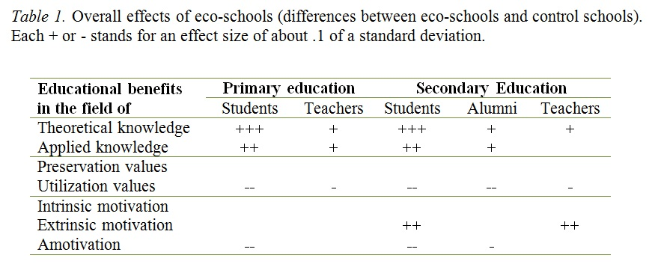
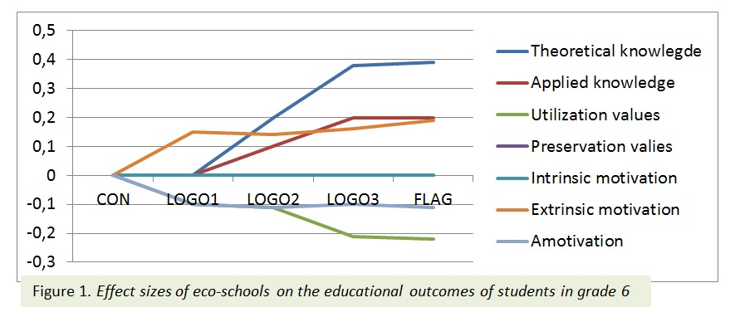
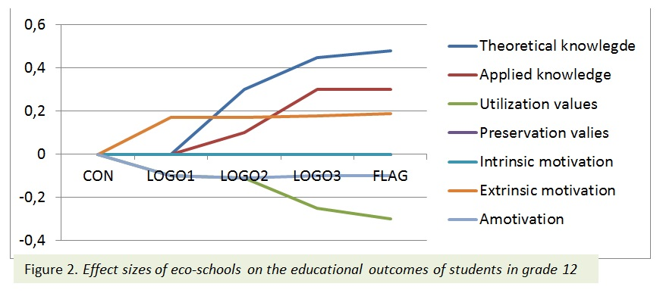
The results also show that the environmental values of eco-school students and teachers are less focused utilizing the natural environment. No effects of eco-schools on the students’ and teachers’ preservation values were found. Eco-schools also have effects in the field of motivation among students and teachers: eco-schools prevent amotivation. Students from eco-schools do not feel that their actions 'will not change anything' for the environment as often as students from control schools. This effect also persists in the long term: it is also there for alumni. On the other hand, the program facilitates extrinsic motivation. Students and teachers from eco-schools indicate more strongly than their counterparts from control schools that they do something for the environment because (they experience that) they have to on account of someone else. Figure 1&2 show the effects of eco-schools on the motivation of students.
What explains these differences?
Our results show that effects are related to environmental policy-making in the school. Shared leadership, common goals, and supporting relations are important to achieve impact. An important finding was that the extrinsic motivation of teachers decreases as joint leadership and supportive relations increase. The effectiveness of eco-schools can be achieved by focusing on shared leadership, common goals and supportive relations. Furthermore, an integrated didactical approach has a small positive effect on students’ theoretical knowledge, and a larger effect on applied knowledge (both in grades 6 and 12). The research also shows that an integrated approach at the same time tempers the utilization values of students and weakens their extrinsic and amotivation. It is plausible to assume that the active and holistic character of such didactical approaches cause these effects. The rules-based approach achieves the opposite: it only results in an increase of the theoretical knowledge, not in applied knowledge, and increases the utilization attitudes of the students.
With regard to green elements at school, we distinguished between their presence, and their use as either decoration, leisure (i.e. as a location for sports or as a location for recreation) and pedagogy (as teaching material and/or classroom). Results show that leisure and pedagogical use of green elements reduce utilization values. The pedagogical use furthermore reduces the extrinsic motivation and amotivation of students in grades 6 and 12.
4. Conclusion
The study shows that the eco-schools project, In Flanders, achieves educational effects. These effects are found both in grade 6 and 12, among students and among teachers, in the short and in the long term, and both in the cognitive and in the affective domain. The largest effects are found for theoretical knowledge. Effects on important precursors of environmental behavior (such as intrinsic motivation, preservation values and applied knowledge) are smaller or absent. The program awakens, most plausibly inadvertently, the extrinsic motivation of students and teachers (I’ll do it because I have to rather than because I want to). Key elements in countering this effect, and in impacting on the precursors of environmental behavior, were observed in the schools’ environmental policy-making, the use of integrated rather than rules-based didactics, and the presence and use of green elements. It seems as though the eco-school program in Flanders is not (yet) reaching its potential, and the findings the current study can be instrumental in doing so.
5. References
UNESCO, 1978. (United Nations Educational, Scientific and Cultural Organization). Intergovernmental Conference on Environmental Education: Final Report. Paris: UNESCO.
Boeve-de Pauw, J. & Van Petegem, P. (2011). The effect of Flemish eco-schools on student environmental knowledge, attitudes and affect. International Journal of Science Education, 33(11), 1513-1538.
Boeve-de Pauw, J. & Van Petegem, P. (2013). The effect of eco-schools on children’s environmental values and behavior. Journal of Biological Education, 47(2), 96-103.
Ozsoy, S., Ertepinar, H., & Saglam, N. (2012). Can eco-schools improve elementary school students’ environmental literacy? Asia-Pacific Forum on Science Learning and Teaching, 13(2), 3.
Bogner, F.X., & Wiseman, M. (2006). Adolescents’ attitudes towards nature and environment: Quantifying the 2-MEV model. The Environmentalist, 26(4), 247-254.
Legault, L. & Pelletier, L.G. (2000). Impact of an environmental education program on students’ and parents’ attitudes, motivation, and behaviours. Canadian Journal of Behavioural Science, 32(4), 243-250.

An investigation of ESD-implementation in Swedish schools by assessing students’ Sustainability Consciousness

Niklas Gericke, Daniel Olsson & Teresa Berglund
Department of Environmental and Life Sciences, Biology
Karlstad University, Sweden
niklas.gericke@kau.se, daniel.olsson@kau.se, teresa.berglund@kau.se
Abstract
In this study we have developed the idea of sustainable consciousness (SC) as a way to investigate the implementation of education for sustainable development (ESD) in Swedish schools. The UN Decade of Education for Sustainable Development drew to an end in 2014 and it is important to investigate its effects. Sustainable development (SD) is commonly defined as the intersection between the dimensions of environment, society and economy. ESD is described as a framework in teaching that incorporates these three dimensions. In this study we have defined the concept of SC as knowingness, attitudes and behavior regarding sustainability within the environmental, economic and social dimensions. Therefore SC represents an individual’s action competence towards SD. The research design is based on a quantitative approach using a survey instrument consisting of 50 items with Likert-type scales measuring SC. Students in Swedish schools that are certified and explicitly taught according to an ESD approach are compared with students in corresponding reference schools. 933 students in grade 6, 840 students in grade 9, and 638 students in grade 12 participated in the study. The results indicate small but significant differences in SC between students from ESD-schools compared to students from REF-schools. A three-dimensional MANOVA analysis showed that for 6th and 12th grade the students from ESD-schools had significant higher values of SC compared to students from REF-schools (p ≤ 0,05). However the ESD-schools in grade 9 had a significant negative effect on students’ SC. Implications for education and the future implementation of ESD are discussed.
Keywords: Education for Sustainable Development, Sustainable Consciousness, Sustainability Education

1. Background and aim
The UN Decade of Education for Sustainable Development (DESD) drew to an end in year 2014. During the preceding decade, numerous schools in the world, including Sweden, have implemented Education for Sustainable Development (ESD) as an explicit teaching approach. In this study, we investigate what impact this teaching approach has had on pupils’ holistic viewpoint of sustainability. In order to undertake the investigation we introduce the concept of sustainability consciousness to represent the holistic viewpoint of sustainability.
In order to accomplish a better implementation of ESD in Swedish schools there has been several external initiatives (‘Eco-schools, ‘Schools for Sustainable Development, ‘School on sustainable way’, ‘The Global School’) that worked together voluntarily with schools to achieve this goal. The schools participating in these endeavors (“ESD-schools”), which include certifications, in-service training and concrete plans to work with these issues in the classrooms, can be regarded as the schools that made most progress with the implementation of ESD in Sweden, and has therefore been selected for the present study.
The globalization process in last decades made it important to educate through an ESD approach in order to broaden the scope of environmental education to also incorporate economic and social dimensions (Borg et al., 2014). Moreover, ESD is considered as an action competence approach that aims to empower students so that they can take action in complex issues regarding sustainable development (SD) (Mogensen & Schnack, 2010). To nurture this action competence it has also become important to incorporate affective aspects and not just cognitive aspects of learning (Littledyke, 2008).
Therefore to be inclusive of the vast goal of ESD-implementation we have developed the concept of sustainability consciousness (SC) which investigates the representation of the environmental, economic and social dimensions of SD, from students’ point of view, by connecting each of these dimensions to aspects of: knowingness, attitudes and behaviors, i.e. both cognitive and affective aspects. In that way we hope to reflect a more comprehensive as well as generalizable view of students’ capacity building and action competence regarding SD-issues.
This study aims to investigate the effects that the implementation of ESD has had on students’ SC in comparison to students in comparable regular schools.
2. Methods
To investigate students’ SC we developed a survey instrument. Based on an analysis of available instruments in the literature we found a questionnaire (Michalos et al. 2011) that met our conditions, i.e. to be related to a holistic view of SD including the three dimensions as well as cognitive and affective aspects. Some of the items in this instrument were removed while other was changed to match the construct of SC. Thereafter the items were categorized to measure knowingness, attitudes or behavior within the environmental, social or economic dimension of SD.
The survey instrument was then validated in two pilot studies, as a consequence two versions of the survey were developed: one with more simplistic language for 6th grade respectively another for 9th and 12th grade. Our final versions of the questionnaire consisted of 50 items distributed as; 17 items of the environmental dimension, 13 items of the economic dimension and 20 items of the social dimension. Of our 50 items, 19 belonged to the knowingness aspect, 14 belonged to the attitude aspect and 17 to the behavior aspect.
Based on empirical data registers from ESD-implementing initiatives (‘Eco-schools, ‘Schools for Sustainable Development, ‘School on sustainable way’, ‘The Global School’) the most prominent ESD-schools in Sweden for compulsory school, (18 schools within grade 6 and 9) and upper secondary school (8 schools within grade 12), were selected respectively. The registers have been used to identify schools that 1) worked the longest with ESD implementation, and 2) shown the highest level of activity. 25 reference schools (REF-schools) that matched the ESD-sample were then selected on the basis to match each of the ESD schools in all aspects except their ESD approach. Therefore, school size (number of students), geographic location and socio-economic factors were selected to be similar and fully comparable to the sample of the ESD-group. One class in each school was then randomly selected to participate in the study resulting in; 934 students from grade 6, 841 students in grade 9, and 638 students in grade 12. The response rate was 81 %.
The data was analyzed in SPSS version 20 in order to investigate differences between students from ESD respectively REF-schools. Multivariate analysis of variance (MANOVA) was used to investigate the full complexity of the students’ SC, while univariate analysis of variance (ANOVA) was used for investigate differences between students’ views of the SD dimensions. In order to estimate the effect size of significant differences between the groups, we also calculated Cohen’s d values, regarding effects as small, medium and large if d ≥ 0.2, ≥ 0.5 and ≥ 0.8, respectively. The Cronbach’s alpha value for the instrument as a whole was 0,903 indicating a good reliability.
3. Results
The results indicate small but significant differences in SC between students from ESD-schools compared to students from REF-schools. The three-dimensional MANOVA analysis showed that for 6th and 12th grade the students from ESD-schools had significant higher values of SC compared to students from REF-schools (p ≤ 0,05). Even more interestingly the results for grade 9 students were opposite, i.e. ESD-schools in grade 9 had a significant negative effect on students’ SC (Wilks’ Lambda, p<0.001).
From the one-dimensional ANOVA analysis we can also see a fragmented effect of ESD-schools on students’ views of SD. When comparing each dimension separately we can for grade 6 see significant differences regarding the environmental dimension, which was more recognized among students from ESD-schools (MD=0,132, p ≤ 0,05). In grade 9 REF-students showed significantly higher mean values for the social dimension (MD=0,112, p ≤ 0,05), while ESD-students in grade 12 recognized the economic dimension significantly higher (0,093, p ≤ 0,05). The effect size were small for these three significant differences (0,2≤ d ≤0,3). For students from all grades and school types the social dimension was recognized the most, see Table 1.
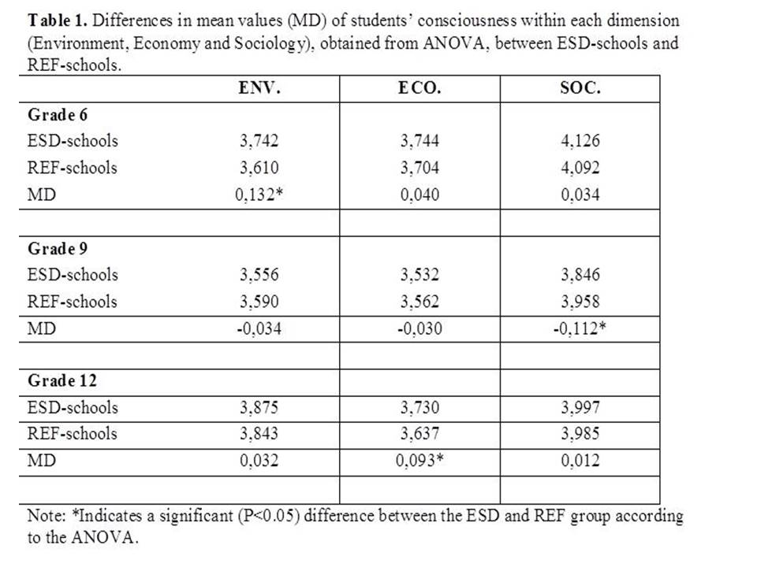

4. Discussion and conclusion
The low effect of ESD-schools on students’ SC is a discouraging result. Even the top schools within the certification system have only a limited impact on pupils’ SC and thereby probably also on their action competence towards SD. However evaluation studies of eco-schools and the effect of environmental values and knowledge has given similar results (Boeve-de Pauw & Van Petegem 2011).
To conclude, the ESD implementation of the UN DESD in the Swedish compulsory school system seems not to have been particularly successful, and raises the question about the proficiency of current ESD-implementation in Sweden. However, this study do not reveal what in the ESD-implementation process that break down, therefore more research is needed.
5. References
Boeve-de Pauw, J., & P. Van Petegem. 2011. "The effect of Flemish eco-schools on student environmental knowledge, attitudes, and affect." International Journal of Science Education 33(11): 1513-1538.
Borg, C., Gericke, N., Höglund, H-O., & Bergman, E. (2014). Subject- and experience-bound differences in teachers’ conceptual understanding of sustainable development. Environmental Education Research, 20(4), 526–551.
Littledyke, M. (2008). Science education for environmental awareness: Approaches to integrating cognitive and affective domains. Environmental Education Research, 14(1), 1-17.
Michalos, A. C., Creech, H., McDonald, C., & Kahlke, P. M. H. (2011). Knowledge, attitudes and behaviours. concerning education for sustainable development: Two exploratory studies. Social Indicators Research, 100(3), 391-413.
Mogensen, F., & Schnack, K. (2010). The action competence approach and ‘new’ discourses of education for sustainable development, competence and quality criteria. Environmental Education Research, 16(1), 59-74.

School experiences enhancing grade nine students’ sustainable actions
Uitto, A.⁽¹, Boeve-de Pauw, J^{(2.} and Saloranta, S. ⁽¹
1) Department of Teacher Education, University of Helsinki, Finland
2) University of Antwerp, Belgium
Anna.Uitto@helsinki.fi, Jelle.Boeve-dePauw@uantwerpen.be, Seppo.Saloranta@helsinki.fi

Abstract
The aim of the study is to investigate how grade nine students’ sustainability-related school experiences and psycho-social factors influence their ecology-related sustainable actions. A large-scale survey was carried out in Finland. A questionnaire was developed to study students’ sustainable school experiences, values, personal norms, self-efficacy belief as well as their sustainable intentions and actions out-side school. Applying the theory of planned behaviour a hypothetical model on the relationship of the studied factors was tested using a survey and a sample of 2,361 grade nine students. The hypothetical model was studied using structural equation modelling (SEM). Excellent model fit showed that in-school agency and prosocial experiences enhance students’ psycho-social factors, especially pro-environmental values and self-efficacy for sustainable actions. Through intentions out-of-school ecology-related sustainable and vicarious actions were enhanced by the psycho-social constructs, especially by the value and self-efficacy constructs in the model. The model suggest that school education for sustainable development should not provide only ecological sustainability-related experiences, but connect prosocial and agency experiences with approaches in which self-efficacy development and pro-environmental values are emphasized.

Key words: SEM model, ESD, secondary school

1. Introduction
At present, Education for sustainable development (ESD) is emerging as the unifying theme for many types of education (UNESCO, 2014). Although there is an agreement on the quality and goals of ESD, there are not much research how well the final goals of ESD have been reached. It is not known how the students experience ESD at school and do the experiences have any influence on students’ own life. The aim of this study is to clarify this question by investigating how grade nine students’ school experiences and psycho-social factors influence their out-of-school ecology-related sustainable intentions and actions.
Factors influencing ecological behaviour have been studied applying the Theory of Planned Behaviour (TPB, Ajzen, 1991) and structural equation modelling as a tool to study factors preceding the behaviour (e.g. Bamberg & Möser, 2007). According to the TBP, an intention to perform a specific behaviour is the immediate antecedent of the behaviour. The intention is predicted by three psychosocial factors: perceived control, attitude to performing a particular act and subjective norm. Although the TPB is widely applied to model adults’ environmental behaviour, less in known on the factors influencing the behaviour of young people. In this study the TPB was applied in the school context.

The research question is:
How students’ self-reported sustainable actions are explained by their psychosocial factors and in-school sustainability-related experiences?
To answer the question we tested a hypothesis that through psychosocial factors school experiences are able to enhance students’ self-reported sustainable actions outside the school (Figure 1).

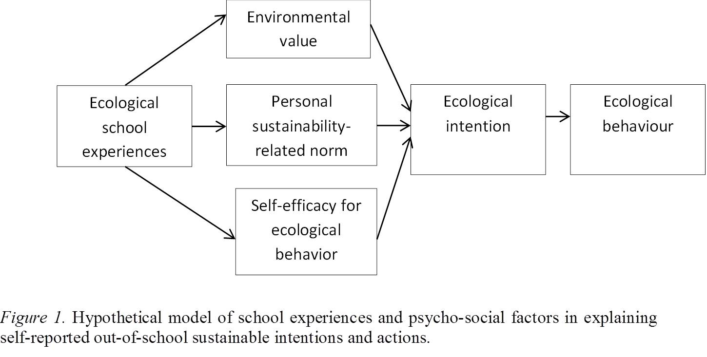
2. Methods
To study factors behind students’ sustainable actions at lower secondary schools, a research project was initiated in 2010 (e.g. Uitto & Saloranta, 2010). The average age of the students was 15. A specific questionnaire with three different 5-point Likert scales was developed the study how often during 7th and 9th grades the students participated specific sustainbilty-related activities in the school (1=very seldom to 5 =very often); agreement with the statements on sustainability school norms and pro-environmental value (1=strongly disagree to 5=strongly agree) and evaluation on their own skills to act sustainable way (1=very poorly to 5=excellently).The number of items per factors varied from 11 to 23. To measure self-reported general sustainable actions, two types of action and the associated intentions were considered: energy saving and vicarious actions for the environment (c.f. Kaiser, Oerke & Bogner, 2007). The items measuring pro-environmental values were developed by applying for instance the study of Milfont and Duckitt (2004). For norms, self-efficacy beliefs, school experiences, intentions and self-reported action items, the activities relating to the objectives and contents of the national curriculum for basic education and eco-school programs (e.g. Breiting, Mayer & Mogensen, 2005) were applied.
A stratified sampling procedure was used to collect a representative data from the whole country. The total number of analysed questionnaires was 2,361. The response rate for the selected schools was 91%, and for the students 73%. 53% of respondents were girls. Explorative factor analyses (EFA) were used to discern the different latent factors meant to tap into the constructs: values, norms, self-efficacy, school experiences, sustainable intentions and actions. Confirmatory factor analyses (CFA) and structural equation models were used to further study the interrelations between the constructs. In these analyses, PASW 18 and Mplus were used (Muthén & Muthén, 2010).
3. Results
In the first step the fit of the hypothetical model concerning the TPB was tested through SEM (Figure 1 for value, norm, self-efficacy, intention and action). The analysis indicated excellent fit for the model (RMSEA = 0.06, CFI = 0.96, TLI = 0.96). In the second step school experiences as background constructs were added in the model. The results indicated excellent fit also for the model (Figure 2). It shows that sustainable and vicarious actions were preceded by corresponding intentions. Sustainable intentions were explained by personal constructs. The model adds the three experience factors and thus provides an answer to the research question of this study. All experience variables had effects on the antecedents in the model. Lowest effect sizes were observed for sustainable ecology-related experiences, larger effects for prosocial experiences, and the largest effects for experiences that contain elements of agency. Values were not preceded by the ecology-related experiences.

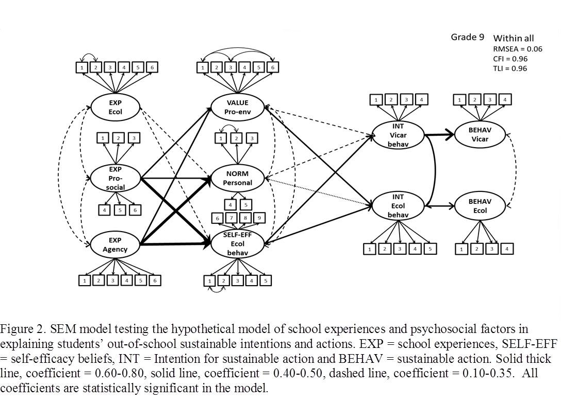
4. Discussion and conclusions
For evaluation, studies on ESD have focused on the management and implementation of ESD programs (UNESCO, 2014), mostly lacking studies on the effects of ESD. The aim of this study was to fill the gap by building a model to assess the effects of ESD efforts in schools. The strengths of the study are the large representative sample from the whole country, and the analytical approach that takes into account complex interactions between the different constructs.
Our study suggests that through personal factors, in-school sustainability experiences can enhance students’ sustainable actions in outside the school. However, there were differences in the impact of varying experiences. Experiences that emphasized ecological sustainability mainly dealt with contents and educational methods, such as sustainable footprint, products’ life cycles and participation to school campaigns. Prosocial experiences emphasized human contexts and through personal factors they had larger influence on the intentions and actions. This indicates that human and societal contexts should be more closely linked to ESD activities. Agency experiences with high level of students’ participation, especially through values and self-efficacy, had the strongest influence on students’ sustainable actions. Experiences in which students share power and responsibility in decision-making with others, are important. Having an active and responsible role at school enhanced students’ sustainable action outside of school. Ecological experiences, which are traditionally felt to be the core of ESD (UNESCO, 2012), need to be critically evaluated for their abilities to motivate students on sustainability issues and be developed to better reach the goals of ESD in school education.
5. References

Ajzen, I. (1991). The theory of planned behavior. Organizational Behavior and Human Decision Processes, 50, 179–211.
Bamberg, S., & Möser, G. (2007). Twenty years after Hines, Hungerford, and Tomera: A new meta-analysis of psycho-social determinants of pro-environmental behaviour. Journal of Environmental Psychology, 27(1), 14-25.
Breiting, S., Mayer, M., & Mogensen, F. (2005). Quality criteria for ESD-schools. Guidelines to enhance the quality of education for sustainable development. Vienna: Austrian Federal Ministry for Education, Art and Culture.
Kaiser, F., Oerke, B., & Bogner, F. (2007). Behavior-based environmental attitude: Development of an instrument for adolescents. Journal of Environmental Psychology, 27(3), 242-251.
Milfont, T. & Duckitt, J. (2004). The structure of environmental attitudes: A first- and second-order confirmatory factor analysis. Journal of Environmental Psychology, 24, 289–303.
Muthén, L. & Muthén, B. (2010). Mplus user guide. Los Angeles, CA: Muthén & Muthén.
UNESCO (2014). Shaping the Future we want. UN Decade of Education for Sustainable Development (2005-2014). Final report. Paris: UNESCO.
Saloranta, S. (2017). Contribution of school’s action culture in the success of primary school sustainability education. Submitted dissertation, University of Helsinki..
Uitto, A., Boeve-de Pauw, J. & Saloranta, S. (2015). Participatory school experiences as facilitators for adolescents' ecological behaviour. Journal of Environmental Psychology. 43, s. 55–65.
Uitto, A. & Saloranta, S. (2010). The relationship between secondary school students’ environmental and human values, attitudes, interests and motivations. Procedia: Social and Behavioral Sciences, 9, 1866-1872.
Uitto, A. & Saloranta, S. 2017 Subject Teachers as Educators for Sustainability: A Survey Study. Education Sciences, 7,8, s. 1-19

